Vehicle 4 – Values and Special Tastes

We are now in a position to create a new brand of vehicle, starting from all the varieties of Vehicle 3, by working on the connections between sensors and motors. They were, up to now, of two very simple kinds: the more the sensor was excited, the faster the corresponding motor ran, or, alternatively, the more the sensor was excited, the slower the motor ran. We did not care what the rules of the dependence were, as long as they were of the nature "the more, the more" or "the more, the less." The vast class of mathematical functions describing such dependences is sometimes called monotonic. Obviously, there is something very simple-minded about creatures governed by such unconditioned likes or dislikes, and we can easily see how such the-more-the-merrier behaviour could lead to disaster. Think what happens in the case of a tendency to follow downhill slopes! Let us consider the following improvement. The activation of a certain sensor will make the corresponding motor run faster, but only up to a point, where the speed of the motor reaches a maximum. Beyond this point, if the sensor is activated even more strongly, the speed will decrease again (figure 6). The same sort of dependence, with a maximum efficiency at a certain level of sensor activation, can be engineered for the inhibitory connections between sensor and motor. We may set the maximum efficiency of the various sensors at any level we choose, and we may even play with dependences having more than one maximum. Any vehicle constructed according to this prescription we will assign to a new brand, labeled 4a. Of course, if you like, you can keep some of the connections of the old monotonic type and mix them with the nonmonotonic ones in every possible combination.

You will have a hard time imagining the variety of behavior displayed by the vehicles of brand 4a. A 4a vehicle might navigate toward a source (as Vehicle 2b would) and then turn away when the stimulus becomes strong, circle back and then turn away over and over again, perhaps describing a trajectory in the form of a figure eight. Or it might orbit around the source at a fixed distance, like a satellite around the earth, its course being corrected toward the source by a weaker stimulus and away from the source by a stronger stimulus, depending on whether the stimulus intensity is on one side or the other of the maximum describing the sensory-motor dependence (figure 7). Vehicle 4a might like one sort of stimulus when it is weak but not when it is too strong; it might like another stimulus better the stronger it becomes. It might turn away from a weak smell and destroy the source of a strong one. It might visit in alternation a source of smell and a source of sound, turning away from both with a change of temperature. Watching vehicles of brand 4a in a landscape of sources, you will be delighted by their complicated trajectories. And I am sure you will feel that their motives and tastes are much too varied and intricate to be understood by the observer. These vehicles, you will say, are governed by INSTINCTS of various sorts and, alas, we just don't know how Nature manages to embody instincts into a piece of brain. You forget, of course, that we have ourselves designed these vehicles. But instincts are a lowly sort of behavior anyway. We can do better. Let us improve on type 4a by adding a new sort of connection between sensors and motors. This time the influence of the sensor on the motor is no longer smooth; there are definite breaks. There might be a range of intensities of sensory stimulation for which the motor is not activated at all and then, under stronger stimuli, the motors are running at full speed. Or else, there might be smooth changes of motor activation for certain ranges, with abrupt changes in between. A very lifelike pattern would be: no activation up to a threshold value of the stimulus, and increasing activation beyond the threshold, starting with a certain fixed minimum (figure 8). You are now experienced in the art of creative invention and will have no difficulty dreaming up more schemes of this sort. In a way these new vehicles, which we call 4b, are already contained in the vast class of vehicles 4a, since abruptness of behavior can of course be simulated with any degree of approximation by functional dependences that are in reality, mathematically speaking, continuous. Moreover, if friction plays a role, as we have already decided it should, thresholds in motor activation would ensue naturally: the vehicle will start moving only when the force exerted by the motor exceeds a certain value, sufficient to overcome the initial friction.

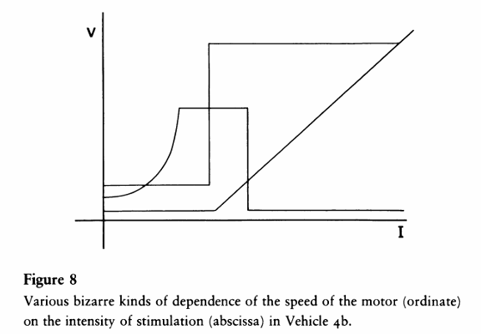

Whatever their origin, thresholds in some behavior patterns make a lot of difference in the eye of the observer. These creatures, the observer would say, ponder over their DECISIONS. When you come close to them with a lure, it takes them some time to get going. Yet once they have decided, they can act quite quickly. They do indeed seem to act in a spontaneous way: none of this passive being attracted one way or the other that was so obvious in the vehicles of the more lowly types. You would almost be tempted to say: where decisions are being made, there must be a WILL to make them. Why not? For all we know, this is not the worst criterion for establishing the existence of free will.